Software Development Fundamentals(Ch1 + Ch2)


Instructor: Mkhombe Sbusiso (University of the Witwatersrand)
Learner Name:
Grade:
Date:
Team Name:
Team Principles:

Instructions:
1. Read each question carefully.
2. No crying, weeping or whining Please! :)
3. You have 60 minutes to complete the test.
4. You get 5% extra for remembering the team name and ALL team principles. :O
5. Answer ALL questions on this paper, every unanswered question has a 5% penalty. :(
6. Lastly, I know we are a team, but no helping each other with this test.
- Which of the following is not a valid variable declaration?
  - int _num1 = 10;
  - int num_1 = 10;
  - int 1_num = 10;
  - int _1num = 10;

- Which of the following statements correctly tell the differences between ‘=’ and ‘==’ in C#?
  - ‘==’ operator is used to assign values from one variable to another variable. ‘=’ operator is used to compare value between two variables.
  - ‘=’ operator is used to assign values from one variable to another variable
‘==’ operator is used to compare value between two variables
  - No difference between both operators
  - None of the mentioned

- What is the correct syntax for the do-while loop ?
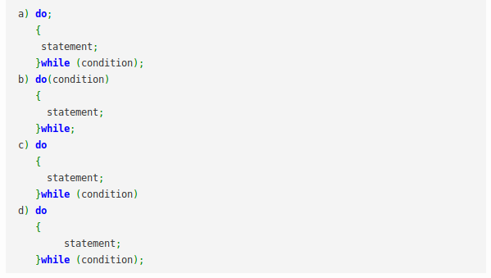

- What does the following code output ?
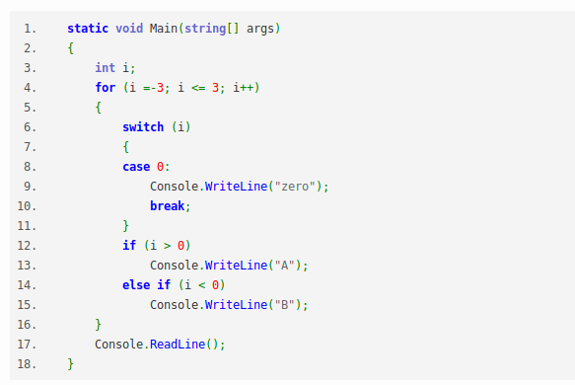

a. B B zero A AA
b. B zero A A A
c. B B B zero A A A
d. A A A zero B B B
- Which of the following is true about try block in C#?
  - A try block identifies a block of code for which a particular exception is activated.
  - It is followed by one or more catch blocks.
  - None of the above.
  - Both a. and b.
- Difference between for and foreach is that:
  - The foreach statement repeats a group of embedded statements for each element in an array or an object
  - The for loop executes a statement or a block of statements repeatedly until a specified expression
  - For repeats fixed number of times whereas foreach repeats for infinite number of times
  - a. and b.
- Default case in switch statements is :
  - Executed if any of the case is not executed
  - Executed if all the cases execute successfully
  - Never executed
  - None of the above

- What is Recursion in C# ?
  - Recursion is another form of class.
  - Recursion is another process of defining a method that calls other methods repeatedly
  - Recursion is a process of defining a method that calls itself repeatedly.
  - Recursion is a process of defining a method that calls other methods which in turn calls this method.
- Boolean variables result in values
  - True and False.
  - 0 and 1.
  - Both a and b.
  - None of the above.
- Which of following loops is executed at least once even if condition is not true:
  - for loop
  - while loop
  - do-while loop
  - None of the above

- Which of the following is an Inheritance mechanism?
  - Using an existing functionality of base class
  - Override the existing functionality of base class
  - Implements new functionality in derived class
  - All of the above
- If you want a method to return information:
  - Add a return statement inside the method.
  - Add void keyword as a return type.
  - Add return statement outside the method.
  - None of the above
- For loop different from while and do while loops in following ways
  - A for loop has a terminating condition given
  - A for loop does not works with a wrong condition like do while loop does.
  - A for loop can not be nested
  - A for loop is not different from while and do while loops
- Process by which we can control parts of a program that can access members of a class is called
  - Polymorphism
  - Abstraction
  - Encapsulation
  - Inheritance
- Data members of a class should always be:
  - Public
  - Private
  - Protected
  - None of the above
- The capability of an object in C# to take number of different forms and hence display behavior as according is known as:
  - Encapsulation.
  - Polymorphism.
  - Abstraction.
  - None of the Above.

17. Consider the following code Snippet:

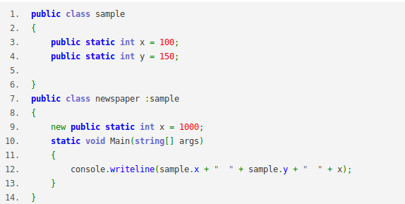

What is the output of the given code ?
a. 100 150 1000
b. 1000 150 1000
c. 1000 150 100
d. 100 150 100

18. Difference between reference type and value type is that
a. Reference types always contains a value but a value type can be null

b. Value type always contains a value but a reference type can be null

c. Both can either have values or can be null

d. b and c

19. What are decision tables and why are they important ?

20. What is the main difference between a high level and a low level programming language?

21. When would you use a constant variable ?

22. Write the number 179 in Binary.

23. What is an access modifier ? What happens when it is set to public for class members ?

24. What is the main difference between reference type and a value type variables?

25. What is an object in OOP?

26. What is the main use of a namespace ?

27. Why do we need classes in our programs ?

28. Define the following?
Inheritance, Encapsulation, Abstraction and Polymorphism.

